Jack Crawford

CS 1051

September 24, 2017

Code: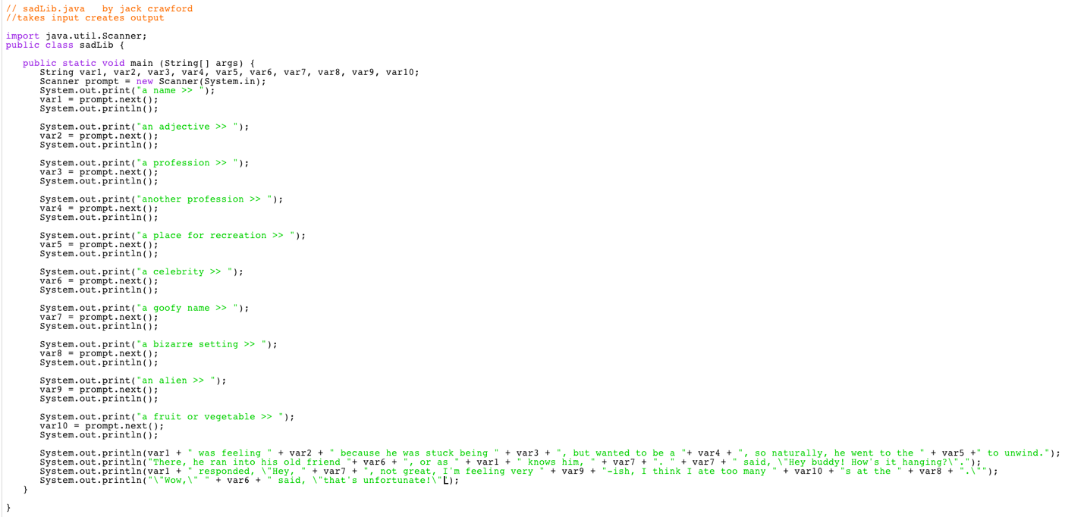Output: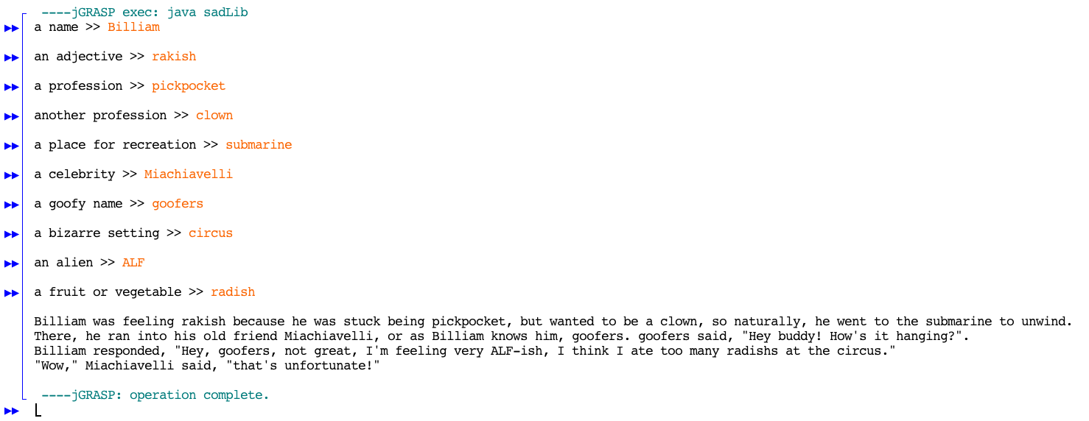

Comments:

Fun!